Project Design Phase-II

Data Flow Diagram & User Stories

|  |  |
| --- | --- |
| Date | 18 October 2022 |
| Team ID | **PNT2022TMID31048** |
| Project Name | **Personal Assistance for Seniors Who Are Self-Reliant** |

Data Flow Diagrams:

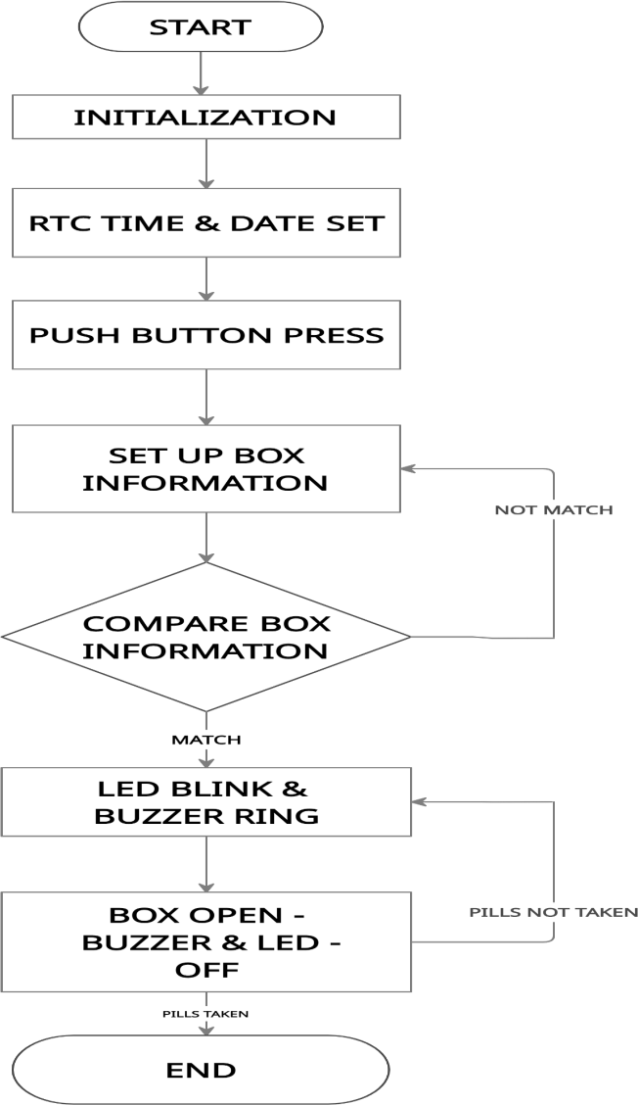

User Stories

|  |  |  |  |  |  |  |
| --- | --- | --- | --- | --- | --- | --- |
| **User Type** | **Functional**  **Requirement (Epic)** | **User**  **Story Number** | **User Story / Task** | **Acceptance criteria** | **Priority** | **Release** |
| Customer (Senior citizen) | Caretaker | USN-1 | As a user, I want to take Medicines on time and monitor my health | I want to take medicines on time | High | Sprint-1 |
| Customer (Alzheimer patient) | Smart medicine box | USN-2 | As a user, I want to take my tablets on time by voice command | I want to take my tablets on time by voice command | High | Sprint-1 |
| Customer  (Mentally idled patient) | Caretaker | USN-3 | As a user, my patient needs to take medicines on time and monitoring the activity | My patient needs to take medicines on time | Medium | Sprint-2 |
| Customer (Coma patient) | Caretaker | USN-4 | As a user, my patient medication time and prescription should load in database for upcoming week | My patient medication time and prescription should be in database list | Low | Sprint-4 |
| Customer (Disabled people’s) | Smart medicine box | USN-5 | As a user, I need to take my medicine in near by places with light notification | I need to take my medicine in nearby places with light notification | Medium | Sprint-3 |